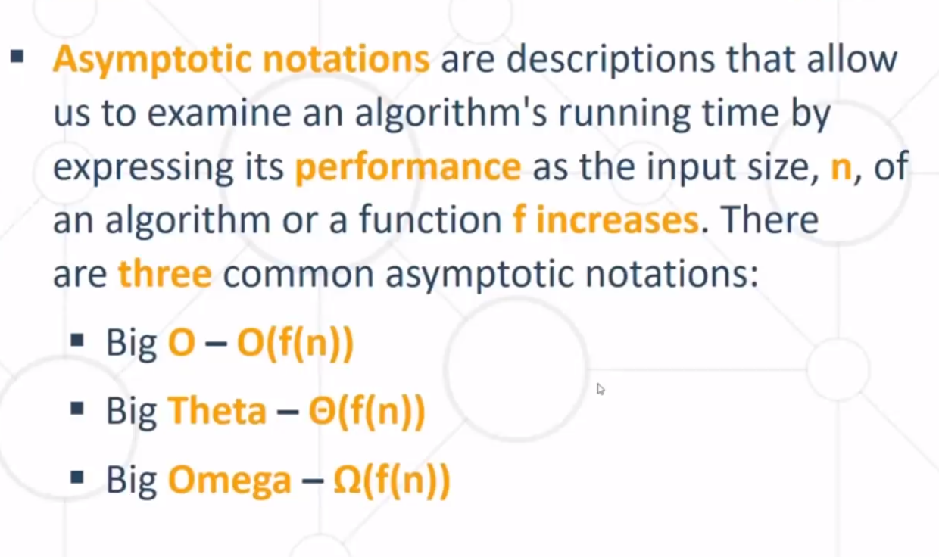

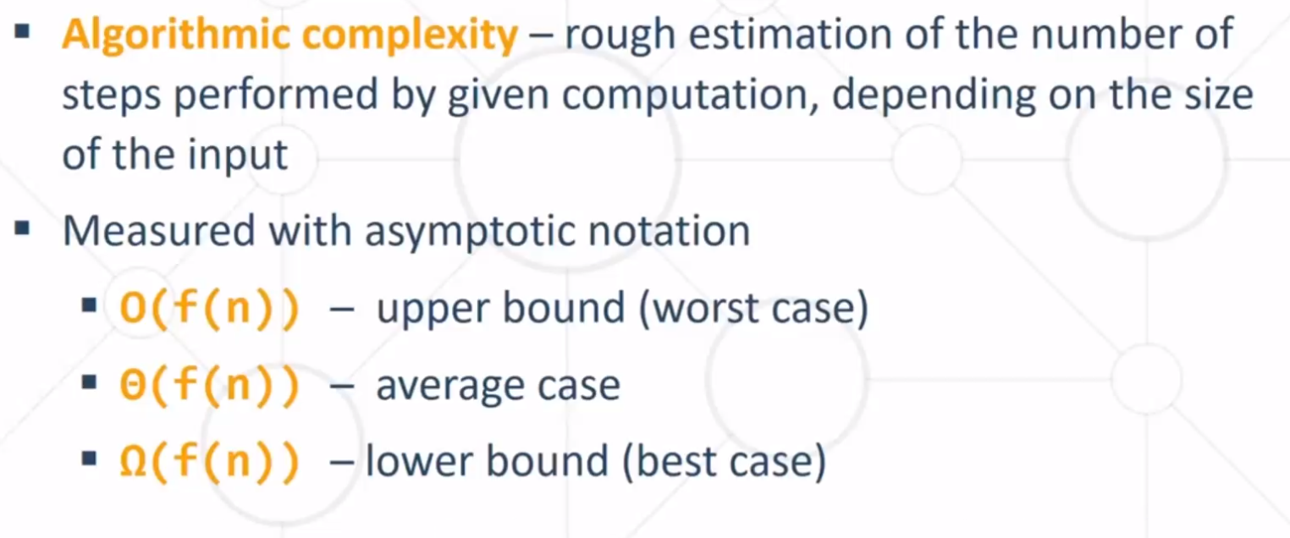

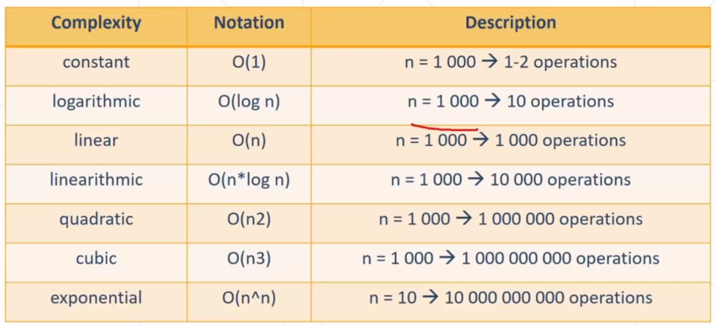

1. Arrays

- Find element in array – O(1)

- Copy array – O(n)

- Rest operation on unsorted array O(n) , sorted array O(log(n))